CO4 ASSESSMENT TOOL-1
Q10. Minimum Spanning Tree (Prim)
Aim
To construct a Minimum Spanning Tree (MST) that connects all nodes with the minimum total cost using Prim's Algorithm, starting from a given node.
Algorithm
- Start from any vertex (Vertex 0).
- Mark it as visited.
- Select the minimum weight edge connecting a visited vertex to an unvisited vertex.
- Add the selected edge to the MST.
- Mark the new vertex as visited.
- Repeat until all vertices are included in the MST.
- Compute the total MST cost.

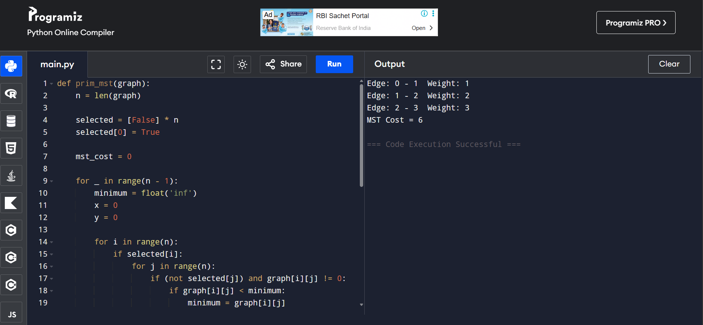
Result
Minimum Spanning Tree Edges:
0 - 1 = 1
1 - 2 = 2
2 - 3 = 3
MST Cost = 6
Time Complexity
O(V²)
(Using adjacency matrix implementation)
Space Complexity
O(V)
(for visited array)

Q74. Minimum Number of Platforms
Aim
To determine the minimum number of railway platforms required so that no train has to wait, using a Greedy Strategy.
Input
n = Number of Trains
arr[] = Arrival Times
dep[] = Departure Times
Sample Input
arr = {900, 940, 950, 1100}
dep = {910, 1200, 1120, 1130}
Output
Platforms = 3
Greedy Strategy
- Sort arrival and departure times separately.
- Use two pointers:
  - i for arrivals
  - j for departures
- If the next train arrives before the current train departs:
  - Allocate a new platform.
- Otherwise:
  - Free a platform.
- Track the maximum number of platforms used simultaneously.

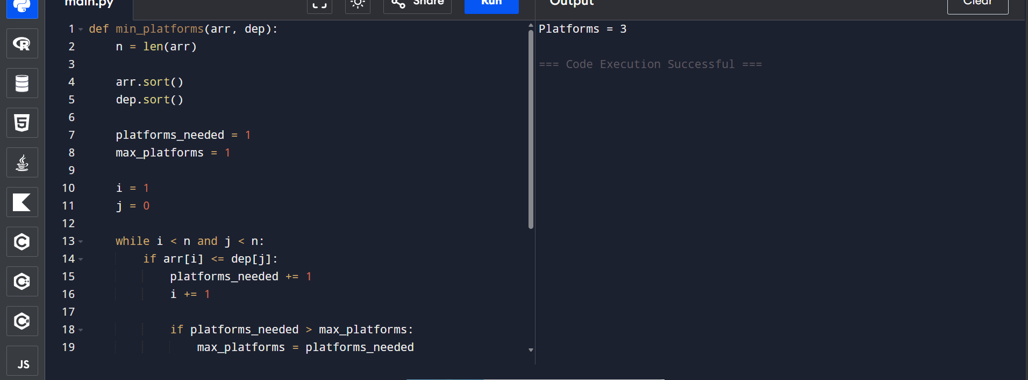
Result
Minimum Number of Platforms Required = 3
Time Complexity
Sorting: O(n log n)
Traversal: O(n)
Total: O(n log n)
Space Complexity
O(1)
(Excluding sorting space)

